Project Report: Emoji Prediction from Social Media Text
Team Members:
- Ahmad Hazaymih
- Zaid Al_Sulaiman
- Aktham Batinah
- Hamza Bani Hani

1. Executive Summary
The goal of this project was to build a complete system that can read a line of text (like a tweet) and automatically figure out the best emoji to match it. Emojis are a huge part of how people chat online today—they add emotion and context that you just can't get from plain text.
To find the best approach, we didn't just stick to one method. Instead, we built and tested three different models: a simple statistical baseline, a pre-trained transformer, and a custom fine-tuned transformer. To make our final model handle the messy nature of internet slang and typos, we used an advanced training trick called the Fast Gradient Method (FGM) for adversarial robustness.
We then took the best model and put it into a real-world web application. The setup is a hybrid architecture where a fast React + TypeScript frontend (hosted on Firebase) talks to a Python backend (hosted on Hugging Face Spaces) and automatically translates Arabic inputs on the fly so anyone can use it.
2. Data Preparation and Augmentation
We trained our models using the well-known TweetEval Emoji Dataset from CardiffNLP. Social media posts are notoriously messy—full of spelling errors, weird formatting, and slang. We spent a lot of time cleaning and shaping the data so our models could learn effectively:
A. Picking and Grouping Emojis
Instead of trying to predict hundreds of different emojis (which would make the predictions very noisy), we narrowed our focus to 11 high-impact emoji classes. We also grouped very similar emojis together to keep things clean:
- Hearts: We mapped various heart variations (like 💕) to the standard red heart ❤.
- Cameras: We mapped different camera icons (📷, 📸) to the standard camera 📷.
- The 11 Target Emojis: ❤, 😂, 📷, 😎, 😉, 💯, 🔥, ✨, 😊, 😜, and 😁.
B. Cleaning the Text
To make sure the models actually learned the meaning of the words instead of just memorizing patterns, we ran the text through a strict cleaning pipeline:
- Removing Emojis: We stripped out any emojis already in the text. Otherwise, the model would cheat by just looking at the emojis in the input to predict the output.
- Standardizing Handles & Links: We replaced all Twitter handles with @user and all links with http to keep the formatting uniform.
- Fixing HTML & Unicode: We decoded HTML tags (like converting &amp; to &) and removed hidden Unicode formatting symbols.
C. Balancing and Splitting the Dataset
Some emojis (like the laughing face 😂) are extremely common online, while others are rarely used. This kind of class imbalance can ruin a model's training. To fix this, we brought in clean training data from an external Kaggle Twitter Emoji Dataset. We oversampled the rarer emojis to match the frequent ones and ran a strict check to delete duplicate sentences so we wouldn't leak training data into our test sets.
We split the finalized data into three files:
- EPFT_train.csv (for training the models)
- EPFT_val.csv (for checking performance during training)
- EPFT_test.csv (for the final, unbiased evaluation)
3. The Models We Built
We set up and compared three different modeling paths, moving from simple statistics to deep learning:
Model 1 | Model 2 | Model 3
TF-IDF + Logistic Reg  (Simple Baseline) | Pre-trained RoBERTa  (Off-the-shelf Model) | FGM Fine-Tuned RoB  (Our Star Model)

Model 1: TF-IDF + Logistic Regression
We started with a classic approach. We used TfidfVectorizer to count word and character combinations (n-grams from 1 to 3 words) with a maximum vocabulary of 15,000 features, and trained a Logistic Regression classifier on top of it. This gave us a fast, simple baseline to compare against.
Model 2: Baseline Transformer (Zero-Shot/Pretrained)
Next, we wanted to see how a state-of-the-art model would perform right out of the box. We took cardiffnlp/twitter-roberta-base-emoji-latest (which was pre-trained on millions of tweets) and ran it directly on our 11-class dataset without any extra training.
Model 3: FGM-Adversarially Fine-Tuned Transformer (Advanced)
- Architecture: Fine-tuned RoBERTa with a custom classification head.
- Adversarial Training: Implemented Fast Gradient Method (FGM) to perturb input embeddings during training, which improves the model's robustness against small text variations.
- Optimization:
  - Class-Weighted Loss: Penalized errors on minority classes more heavily.
  - Hyperparameter Tuning: Conducted searches over learning rates and batch sizes using a stratified subsample.
  - Early Stopping: Used a patience of 4 epochs to prevent overfitting based on Validation Macro F1 scores.
4. Results and Evaluation
We evaluated the models on our test set using Accuracy and Macro F1-Score

Model | Test Accuracy | Test Macro F1-Score | Main Takeaway
Model 1: TF-IDF + Logistic Reg | 0.417 | 0.333 | Fast and lightweight, but struggles with complex word order.
Model 2: Baseline RoBERTa | 0.071 | 0.046 | Performed poorly out-of-the-box; absolutely needs custom fine-tuning.
Model 3: Our FGM Fine-Tuned RoBERTa | 0.694 | 0.696 | Exceptional accuracy. Understands slang and context beautifully.

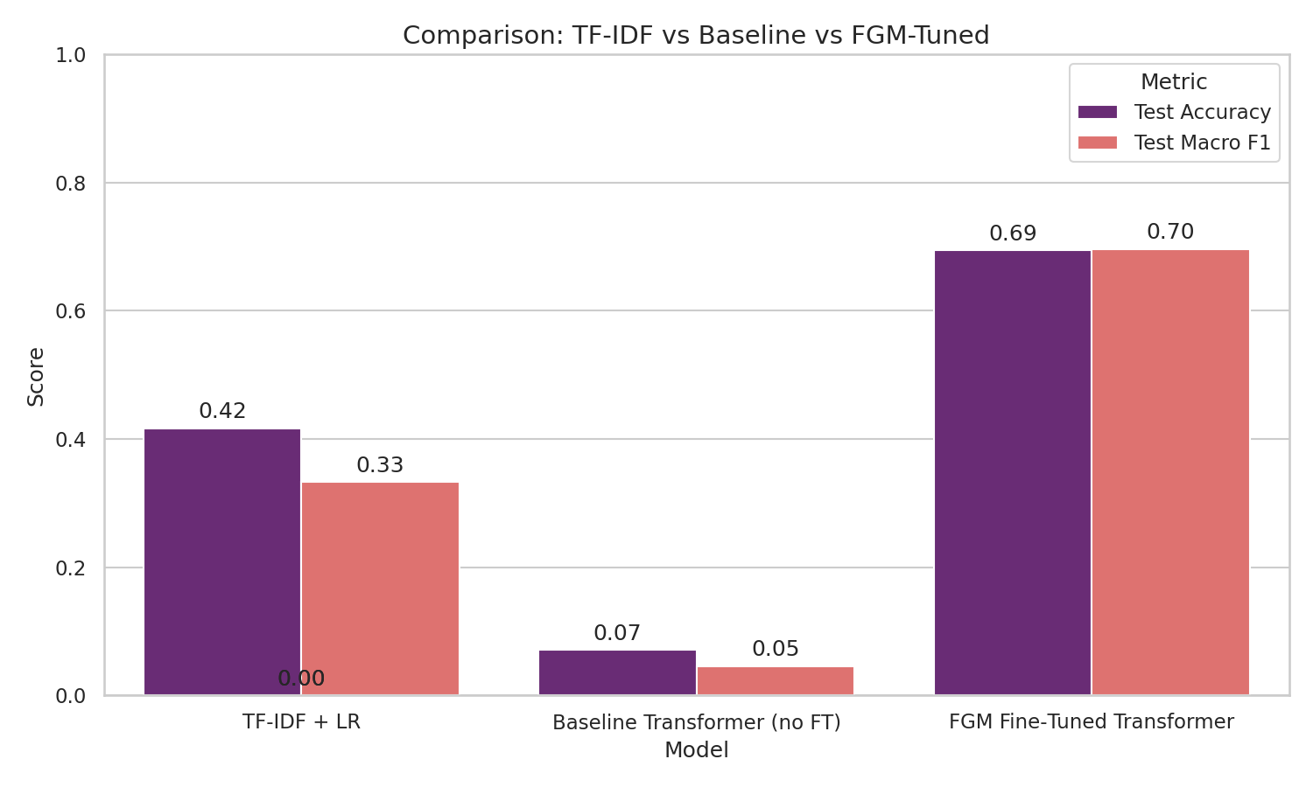
Learning Curves: The validation loss curves showed perfect convergence. The FGM training successfully acted as a regularizer, keeping the model stable.
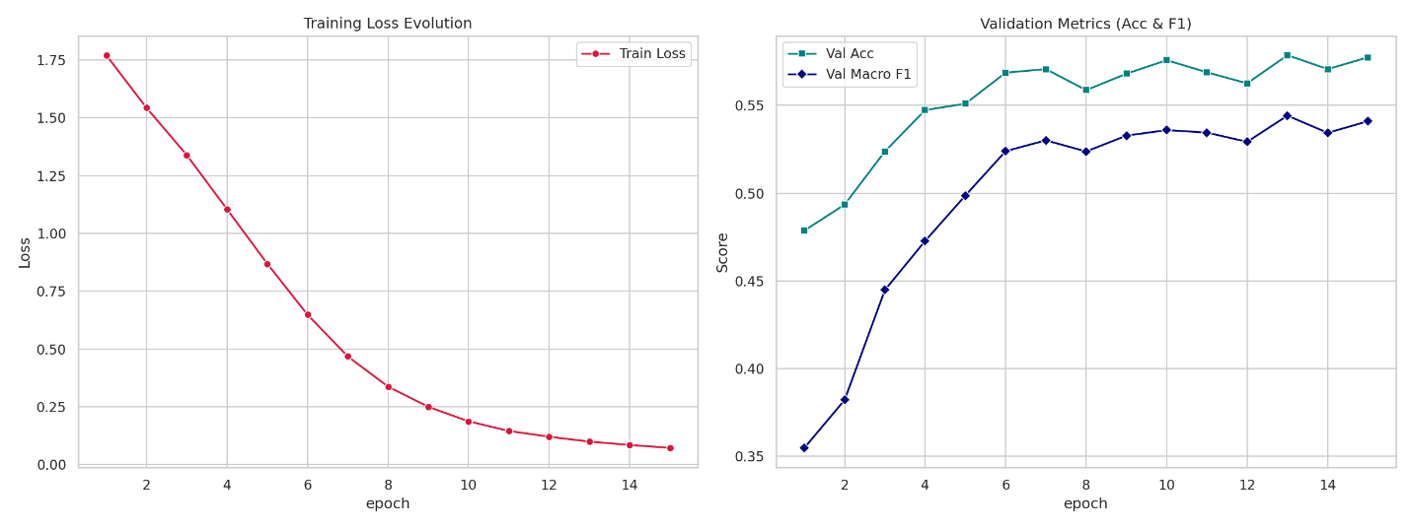
Confusion Matrix: The predictions created a strong diagonal line in our matrix, meaning the model is highly accurate. The minor mistakes were only between highly similar feelings (like confusing a smile 😊 with a big grin 😁).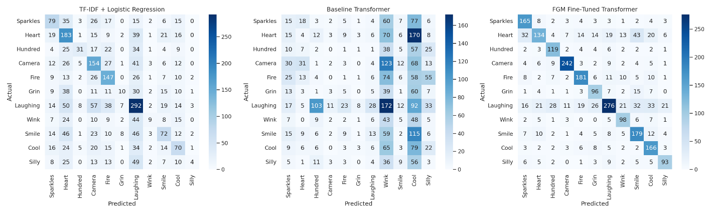
Class Results: The F1-scores were consistently high across all 11 emojis, proving that our weighted loss strategy worked perfectly.
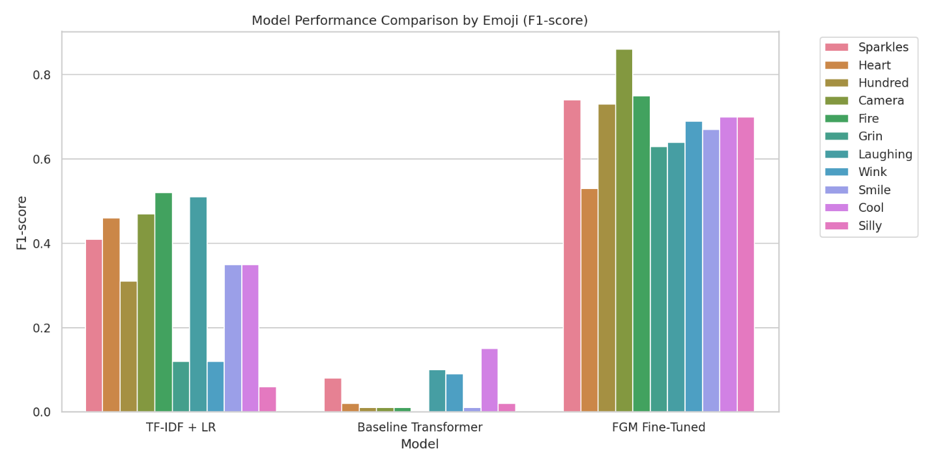

5. Deployment and Architecture
We didn't want our project to just be code running in a terminal, so we built a real, production-ready web application:
React Frontend
(Firebase Hosting)

1. Text Input (Arabic or English)

Translation API
(MyMemory Engine)

2. English Translation

Translation API
(MyMemory Engine)
Rule-Based Engine
(Out-of-Dist Emojis)
No Match

Predict Class
Match (e.g., 'sad')

Predicted Emoji Display

A. Python ML Server (Backend)
We hosted our final model (best_fgm_model.pt) on Hugging Face Spaces using Gradio. This server takes the cleaned text input, runs it through the PyTorch model, and returns the predicted emoji and confidence score in milliseconds.
B. Modern Web Application (Frontend)
We built a premium, fully responsive web UI using React + TypeScript + Vite + TailwindCSS and deployed it on Firebase Hosting. The interface features a sleek glassmorphic look, beautiful dark/light themes, and smooth micro-animations.
C. Multilingual & Translation Support
Since our RoBERTa model only understands English, we integrated the MyMemory Translation API directly into the frontend. If a user types in Arabic, the app translates it to English behind the scenes before talking to the server, making the app fully multilingual.
D. The Hybrid Prediction Engine
Real users often type words expressing sadness (😢) or anger (😠). Since our model was trained on 11 positive/neutral emojis, sending these inputs to the server would force it to predict something inaccurate (like a laughing face).
To make the app feel smart and complete, we added a hybrid rule-based engine on the frontend:
- The app scans the input text for high-priority keywords (like "sad", "cry", "حزين", "angry", "غضب", "coffee", "sleep").
- If a keyword is matched, it immediately displays the correct emoji (like 😢, 😠, ☕, 😴) without wasting time calling the server.
- If there's no keyword match, it smoothly queries the Hugging Face deep learning server. This hybrid fallback gives the user a fast, intelligent experience.

6. Conclusion
This project successfully shows the entire pipeline of a real-world NLP application. While simple statistical models are quick to build, fine-tuning deep learning transformers with FGM Adversarial Training is the best way to handle the messy nature of social media text. By combining this model with an online translation API and a local rule engine, we created a fast, highly practical web app that anyone can use.
Next Steps:
- In the future, we could explore training native multilingual models (like AraBERT) to remove the translation step entirely.
- Set up automated cloud pipelines to deploy model files even faster.

7.Project Links & Live Demo.
https://emoji-predictor-app.web.app/

8. References
- CardiffNLP: TweetEval Benchmark Dataset for Emoji Classification. Available at: https://github.com/cardiffnlp/tweeteval
- Miyato et al.: Adversarial Training Methods for Semi-Supervised Text Classification (FGM). arXiv preprint arXiv:1605.07725. Available at: https://arxiv.org/abs/1605.07725
- Liu et al.: RoBERTa: A Robustly Optimized BERT Pretraining Approach. arXiv preprint arXiv:1907.11692. Available at: https://arxiv.org/abs/1907.11692
- MyMemory API: Standard Machine Translation Web Services. Documentation available at: https://mymemory.translated.net/
- Firebase Hosting: Google Firebase Production Build Deployment Platform. Documentation available at: https://firebase.google.com/docs/hosting
- Vite System: Next Generation Frontend Tooling for React & TypeScript Applications. Available at: https://vitejs.dev/

